**Construct BST from Postorder:-**

Given postorder traversal of a Binary Search Tree, you need to complete the function **constructTree()** which will create a BST. The output will be the inorder of the constructed BST.

**Input:**  
The constructTree() method consist of two arguments as input, the array consisting of the **post order traversal** and the **size of the array**.

**Output:**  
Print the Inorder traversal of the constructed BST.

**Constraints:**  
1 <= T <= 100  
1 <= N <= 100

**Example:  
Input:**  
2  
6  
1 7 5 50 40 10  
9  
216 823 476 429 850 93 18 975 862

**Output:**  
1 5 7 10 40 50  
18 93 216 429 476 823 850 862 975

**Explanation:  
Testcase 1:** The BST for the given post order traversal is:  
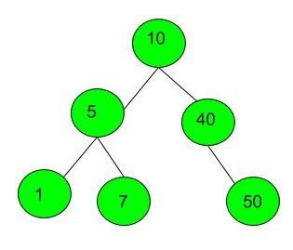

Thus the inorder traversal of BST is: 1 5 7 10 40 50.